6A^{th} Grade: Unit 7, Lesson 3

- What is the value of the missing dimension in the image shown?
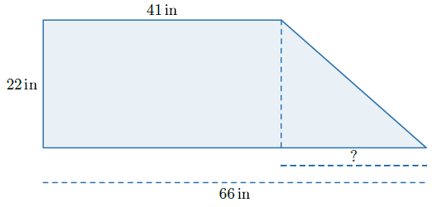
25 inches

- What is the area of the rectangle shown?
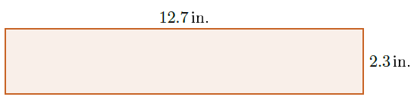

29.21 square inches

- What is the area of the triangle shown?
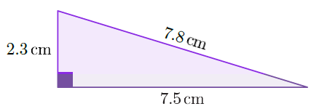
4.6 cm²

